CHEMICAL ENGINEERING TRANSACTIONS  VOL. , 2023 | A publication of
The Italian Association
of Chemical Engineering
Online at www.cetjournal.it

Guest Editors: David Bogle, Flavio Manenti, Piero Salatino
Copyright © 2023, AIDIC Servizi S.r.l.
ISBN 979-12-81206-04-5; ISSN 2283-9216

Evaluation of water leaching on properties of woody biomass for biocarbon production
Liang Wang*, Øyvind Skreiberg
ª SINTEF Energy Research, Sem Sælands vei 11, NO-7034 Trondheim, Norway

corresponding.author liang.wang@sintef.no
Biocarbon is an attractive option to replace fossil carbon for metal production with the benefits of reducing greenhouse gas emissions and CO₂ footprint. Nowadays, biocarbon is mainly produced from virgin wood through pyrolysis. As a carbon and energy-intensive industry, large amounts of biocarbon are needed in the metallurgical industry. With consideration of the increasing price of virgin wood and demands from other industries for this material source, it is necessary to broaden the biomass resource base. Woody biomasses with high carbon content and superior mechanical properties are still preferred for producing biocarbon. Therefore, various non-conventional woody biomasses are considered for biocarbon production, including forest residues, waste wood, etc. However, compared to virgin wood, the non-conventional woody biomasses often have high content of inorganic elements. During pyrolysis, the inorganic elements present in the feedstock might cause problems for the equipment and influence the reactions. A major fraction of the inorganic elements will remain in the produced biocarbon, which negatively affects the conversion of the biocarbon during metal production processes and some inorganic elements may influence the quality of the metal products as well. Demineralization is a process widely used for pretreatment of biomass materials that are rich in or contaminated with inorganic elements. Water leaching is still the most popular option as it is rather easy to conduct with low costs and fewer challenges for treating leachates. The objective of this paper was to compile and review the current literature concerning the demineralization of non-conventional woody biomasses through water leaching. The review revealed that leaching conditions (i.e., temperature and time) need to be carefully selected with consideration of the content and present form of the inorganic elements in different biomass materials. Moreover, the water leaching efficiency under given conditions is also related to the physical properties of the biomass material (i.e., particle size). In addition to the inorganic elements, the water leaching might also affect the organic composition (i.e., extractives) of the biomass materials. The properties of leached biomass materials should be characterized, which can be used for predicting the yield and quality of the produced biocarbon. Optimal water leaching procedures and conditions need to be identified and tested for maximizing the reduction of undesired inorganic elements and limiting the negative effect of properties of non-woody biomasses for biocarbon production.
  - Introduction
The metal production industry is energy-intensive and consumes large amounts of carbon each year. Consequently, about 10% of annual anthropogenic CO₂ emissions are ascribable to the GHG emissions from the metallurgical industry (Surup, Trubetskaya, and Tangstad 2020). Nowadays fossil-based carbon (i.e., metallurgical coke) is mainly used for metal production processes. It is therefore critical to identify, test and use alternatives to fossil-based carbon, in order to reduce the impacts of the metallurgical industry on the environment and CO₂ emissions as well(Wang Liang et al. 2022). Biocarbon produced from renewable biomass materials is a promising option, which has gained continuous interest over the past decades. In comparison to other biomass materials, woody biomasses often have superior properties as a source for producing biocarbon that is used for metal production processes. Woody biomass from the forest sector is an abundant resource for biocarbon production (Singhal et al. 2023a). However, compared to conventional woody biomass (i.e., sawdust, stem wood chips), non-conventional woody biomasses have heterogeneous properties and drawbacks for producing biocarbon that is useable for metallurgical applications(Singhal et al. 2023a). One of the main drawbacks of non-conventional woody biomasses is the high content of inorganic elements that can retain in the produced biocarbon. The presence of inorganic elements in the biocarbon can give negative effects on the metal production processes in different ways (Wang Liang et al. 2022). Therefore, it is critical to reduce amounts of the unwanted inorganic elements in the biocarbon. Water leaching has been studied and tested for washing away the inorganic elements in the biomass before further thermochemical conversion of it. There are different factors that will affect the efficiency of leaching out the inorganic elements in biomass materials(Liaw and Wu 2013a). In addition, leaching treatment will also impact the physio-chemical properties of the biomass materials, which further affect the conversion behaviours of the biomass and yields and properties of products consequently(Vassilev and Vassileva 2019; Giudicianni et al. 2021). The aim of this work is to critically review key aspects related to the water leaching of non-conventional woody biomass. The first part of this review briefly introduces the presence of inorganic elements in biomass materials. The second part focuses on a review on laboratory studies on water leaching of biomasses. It covers factors affecting water leaching efficiency and key findings available in the literature. The third part of the review is devoted to discussions on influences of leaching on yields and properties of products from non-conventional woody biomasses, focusing on the application of biocarbon for metal production. In the end, summary and outlook are provided regarding challenges, obstacles and possibilities for efficient water leaching of non-conventional woody biomass, in order to produce biocarbon with desired properties for metal production.
  - Concentration and form of inorganic elements
The inorganic elements in the biomasses are normally nutrients that are essential for plant growth. In general, the inorganic elements in the biomasses can be grouped as major elements including Ca, K, Mg, P, S, Si and Al, which often are abundant in most biomass materials with high concentrations (i.e., >1000 ppm)(Werkelin et al. 2010). On the other hand, inorganic elements such as Mn, Fe, Zn and Ti are regarded as minor ash elements(Vassilev et al. 2012). The inorganic elements are taken by the plant from surrounding environment in aqueous solutions, mainly through the roots. For most of the inorganic elements, uptake of them involves the transportation of ions, through controlled and active processes(Giudicianni et al. 2021). For the Si and Al, the uptake of them might be a passive process, as they can be in aqueous solutions and from external contaminations or directs (i.e., sand and soil)(Werkelin et al. 2010). The concentration of inorganic elements in different biomasses are significantly different, even for the different parts from one plant. For the woody biomasses, previous studies reported that the concentrations of all inorganic elements are the lowest in comparison to those in bark and forest residues(Werkelin et al. 2010; Zevenhoven et al. 2012; Vassilev and Vassileva 2019). The bark from trees often has high content of Ca and Al. The concentrations of Ca in the bark are especially high, which can be in the range of 5000-25000 ppm(Werkelin et al. 2010). Whereas the twigs are rich in K, P, S and Cl. The concentrations of K and P in the twigs can be as high as respectively 9500 ppm and 3500 ppm, which are respectively about 2-3 times and about 100 times higher than those in bark and stem wood(Werkelin et al. 2010). Even for the bark from one tree, the concentration of inorganic elements can also be quite different. For example, the content of K in stem wood bark is generally lower than that of branch bark. The inorganic elements such as K and P are essential nutrients needed for the growth of plants, which are often concentrated in the biological active parts of one plant, such as twigs, needles and bark(Liu and Bi 2011). In addition, the concentration of inorganic elements varies considerably between different woody biomasses, even for the stem wood. It was reported that the concentration of K in aspen is about 8500 ppm, which is about 1.5 times higher than in spruce, birch and pine wood(Werkelin et al. 2010). In addition to the absolute concentration, the chemical form of the inorganic elements is also critical, affecting the transformation chemistry of them during thermochemical conversion processes and specification of them in the final conversion products, such as biocarbon. The inorganic elements are generally present in the biomass materials in various forms, including oxides and hydroxides, silicates, sulphates, sulphites and sulphides, phosphates, carbonates, chlorides and nitrates(Vassilev and Vassileva 2019). Generally speaking, the virgin biomasses contain high amounts of carbonates, chlorides, oxalates and phosphates(Vassilev et al. 2012). The concentrations and distribution of them in one kind of biomass depend on genetics, growing conditions, harvest time and storage and processing conditions before the final conversion and utilization(Giudicianni et al. 2021).
  - Water leaching of woody biomass
    - Water leaching
The leaching of biomass has been studied using different leaching agents. The inorganic elements in biomasses can be generally grouped based on their solubility in different leaching agents, which also indicate their associations in biomass materials. The inorganic elements in biomasses, according to their solubility, are in categories of dissolved salts, organically bound matter, included mineral matter and excluded matter(Vassilev and Vassileva 2019; Werkelin et al. 2010). Dissolved salts are normally found as ions (K⁺, Na⁺, Ca²⁺, Cl–, HPO₄^{2–,} SO₄^{2–}) in the fluid matter in the plants, which are water-soluble(Werkelin et al. 2010). The dissolved salts have different mobility during water leaching in the order of phosphates < carbonates < sulphates < chlorides < nitrates(Vassilev and Vassileva 2019). It has been reported that water leaching can considerably reduce the content of alkali metals (potassium and sodium), sulfur, chlorine, phosphor, and alkali earth metals to a certain extent. However, water leaching is ineffective in removal of Si, Al and Fe in biomass materials. Acids, as leaching agents, have a stronger capacity to remove organically associated and water-insoluble salts. However, acid-washed biomass materials can not be used for thermochemical conversion processes, which must be neutralized for avoiding corrosion of the conversion facilities and eliminate issues related to health of operators(Singhal et al. 2023a). Extra steps and water are needed for neutralizing the acid washed biomass materials, which are economic and environmental challenges for the industry(Singhal et al. 2023a). On the other hand, water leaching is a simple and practically feasible way to reduce the content of inorganic elements that are unwanted in biomass for thermochemical conversion processes. In addition, the leachates from water leaching of biomass are much easier to handle, which has the potential to be further used with considering the high content of inorganic elements such as K and P that are technically recyclable nutrients(Giudicianni et al. 2021). Therefore, water leaching of biomass materials, in comparison to using other leaching agents such as acid, is attracting more attention due to its operational simplicity and low investment costs.
    - Leaching methods
In previous studies, water leaching of biomass materials, including non-conventional woody biomasses, were conducted by using laboratory batch and semi-continuous setups. For the batch leaching process, the biomass material is loaded in a container and mixed with either distilled water or deionized water. The biomass material, for example chips or powders with different sizes, were immersed in the water. In order to enhance leaching efficiency, the container mixture of biomass and water was shaken on a shaker with a certain shaking frequency(Singhal et al. 2023a). The other way is to keep the container still, but stirring the mixture continuously with for example a magnetic stirrer(Stefanidis et al. 2015). After washing under certain condition and time, the solid were rinsed first and then dried to determine the concentration of remaining inorganic elements. The mixture of leaching solvent and rinsing water would also be analyzed for elemental concentrations. There are several advantages of a batch leaching test that are easy to control and it is easy to manipulate leaching conditions and repeat leaching procedures to get repeatable results. However, for the batch leaching process, there might be resorption of water-soluble inorganic elements that do not end up in the leachates(Singhal et al. 2023a). Considering this, a semi-continuous water washing method was proposed to enhance direct contact of water and biomass materials and improve leaching efficiency(Wang et al. 2023; Liaw and Wu 2013b). The biomass material was loaded and trapped (i.e., with net or sieve) into a reactor and the water is used as mobile phase to continuously flush the solid material, which also brings the leached aqueous solutes out of the reactor. The leaching was completed after desired washing time(Liaw and Wu 2013b). Then the leached solid was filtered and dried for further analysis of concentration of inorganic elements. The semi-continuous leaching process was mainly conducted to study effect of leaching conditions on concentration of remaining water-soluble elements in biomass materials without analysis of the content of them in the leachates(Wang et al. 2023).
    - Leaching conditions
Efficiency for leaching water-soluble inorganic elements in biomass materials can be affected by several factors, including leaching time, water temperature and solid-liquid mixing intensity. Effect of leaching time on concentration of Norway spruce (Picea abies) bark has been studied by Singhal et al.(Singhal et al. 2023a). Figure 1 shows the effect of leaching duration on the removal efficiencies of two abundant inorganic elements in the studied bark. For both K and P, the continuous removal of them can be observed from Figure 1. A much higher concentration reduction of K can be observed, which is ranged from 30% at 0 min to about 80% at 180 min. It was also reported that rather intensive and rapid removal of K was obtained till 10 min(Singhal et al. 2023a). On the other hand, removal of P by water leaching was not so evident, even after 180 min leaching treatment. The continuous removal of inorganic elements in the biomass materials through batch water leaching indicates that different leaching mechanisms govern the leaching process over an extended time. In the first stage, inorganic elements with high solubility dissolve rapidly in the water(Liaw and Wu 2013a). With longer leaching time, organics in the biomass will also be leached, including acid, propanoic, lactic acid and phenols. The dissolving of these organics causes a change of pH in the leachates, which will facilitate the removal of some ion-exchangeable and acid-soluble inorganic elements that have poor solubility in the water(Liaw and Wu 2013a; Singhal et al. 2023a). In addition to leaching time, an increase of water temperature can also promote the dissolving of inorganic elements in the water(Fu et al. 2021). A combination of long leaching time and high-water temperature (i.e., 50-75°C) has been proposed as an efficient way to reduce the content of ash and water-soluble inorganic elements in biomass(Singhal et al. 2023a). Solid-liquid mixing intensity is the other factor that has been considered and studied for the batch water leaching process. As reported in previous studies, the mixture of biomass and water was stirred or shaken along the leaching process(Giudicianni et al. 2021). It enhances the penetration of water in the microstructures of biomass materials and contacts between water and inorganic elements(Skoulou et al. 2009). The efficiency to leach out the water-soluble elements in the biomass materials was increased consequently.
Figure 1: Effect of leaching duration and agents on removal efficiencies of K and P in spruce bark(Singhal et al. 2023a)
  - Effect of leaching on properties of woody biomass
    - General properties
The main purpose of leaching woody biomass is normally to reduce the content of ash and unwanted inorganic elements that play negative roles for further thermochemical conversion processes.
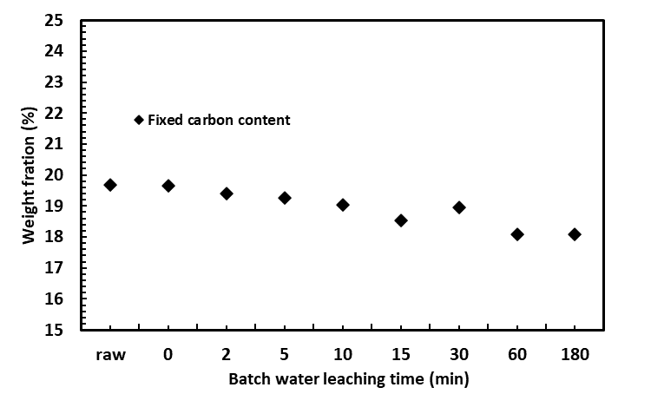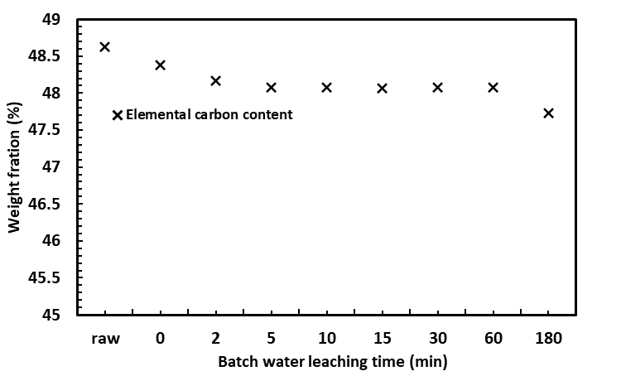
Figure 2: Effect of leaching on fixed carbon and elemental carbon content of spruce bark
The water leaching can also impact general properties of woody biomasses to a certain extent. Singhal et al. conducted intensive leaching studies on Norway spruce bark with detailed characterization of leached bark(Singhal et al. 2023a). It was found that, in addition to ash content, the content of fixed carbon and elemental carbon of the leached bark decreased as well(Singhal et al. 2023a). During the leaching process, part of the organic substances in the woody biomass can be extracted with water. One example of such organic substances is extractives in the woody biomass, which account for 5–30% of wood biomass on dry weight basis(Hörhammer et al. 2018). The extractives are often hydrophilic with composition of for example polyphenols, terpenes and fatty acids(Hörhammer et al. 2018). With long enough leaching time, the extractives can be either dissolved in the water or mechanically detached from the parental woody biomass, which results in decrease of carbon content in the leached materials.
    - Inorganic elements
The effect of water leaching on ash content of woody biomass is highly variable. Figure 3 shows selected results reported in previous work dealing with water leaching of pine and spruce bark(Stefanidis et al. 2015; Singhal et al. 2023a). The pine and spruce bark were both washed in a batch reactor at room temperature with different durations. As shown in Figure 3, the ash removal efficiency can be considerably different upon leaching time and size of sample particles. As reported by Stefanidis's work, the highest ash removal efficiency was obtained from the ground pine bark with a smaller size and long leaching time of 72 hours, which is about 4 times higher than that of the value obtained from the same sample but with 24 hours duration(Stefanidis et al. 2015). In the same study, evidently lower ash removal efficiencies were obtained from the sample with larger particle sizes. In the other work, spruce bark, as small chips with size of 5 mm, was leached by water with different durations. It is interesting to see that the efficiency for washing away the ash is about 7% with a leaching time of 0 minutes(Singhal et al. 2023a). It means the spruce bark sample was poured with water within 5-8 second and the leachate was simultaneously collected from the bottom of the batch leaching reactor(Singhal et al. 2023a). However, even with extending of leaching time to 3 h, the ash removal efficiency just increased to 11%(Singhal et al. 2023a). The collected data indicate that efficiency to leach out ash in biomass materials can be related to physio-chemical properties of biomass such as particle size and biomass species.
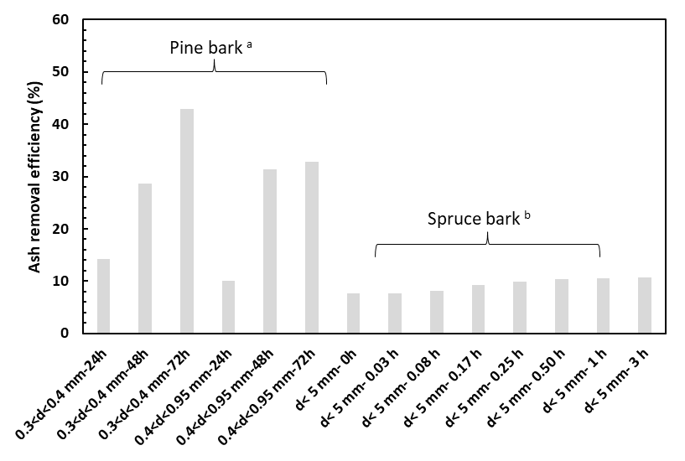
Figure 3: Effect of water leaching duration on removal efficiencies of ash in pine and spruce bark. (a) data from from (Stefanidis et al. 2015), (b) data from (Singhal et al. 2023a).
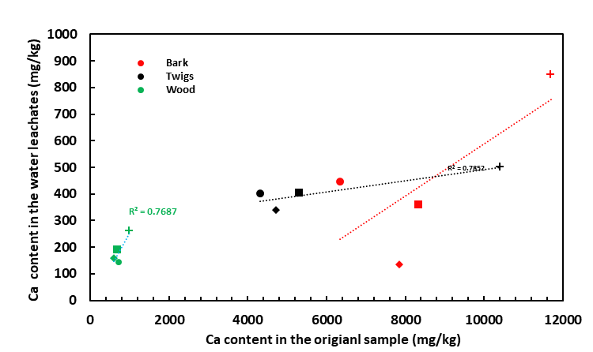
Figure 4: Amount of total and leachable K and Ca in spruce wood, bark and twigs
Figure 4 displays concentration of water-soluble K and Ca in the spruce bark, twigs and wood against the concentration of the two elements in three dried samples as reported by Werkelin et al.(Werkelin et al. 2010). It clearly shows that there are significantly different concentrations of the two elements in the different parts of the tree. Good correlations were found between concentrations of total K and water-soluble K in the studied woody biomasses(Werkelin et al. 2010). On the contrary, the Ca has poor solubility in water, although the total concentrations of Ca in the initial dried samples are much higher. It has been reported that over 80% of monovalent ions of alkali metals can be leached out by water leaching even for a short time of about 10 minutes(Werkelin et al. 2010). On the other hand, divalent ions of earth alkali metals (Mg²⁺ and Ca²⁺) are rather difficult to remove only by water leaching but can be readily leached by acid(Werkelin et al. 2010; Singhal et al. 2023b). Therefore, the alkali earth metals have high tendency to remain in the water-washed woody biomass.
  - Conclusions
Water leaching is an efficient way to reduce the concentration of certain inorganic elements in woody biomass. The efficiency for leaching away the inorganic elements are affected by several factors including leaching condition and procedures and physio-chemical properties of initial biomass materials. It is important to conduct detailed analyses of the biomass materials and take into account the specific chemical composition of each biomass component before the water-leaching treatment. For the current published works reporting water leaching of woody biomass, most of them started by using ground materials with small particle size. Further work focusing on biomass materials with a wide range of sizes are needed, which gives more practical indication for further industrial applications.
Acknowledgments
The authors acknowledge the financial support from the Research Council of Norway and the BioCarbUp and BioCarbUpgrade project industry partners: Elkem AS - Department Elkem Technology, Eramet Norway AS, Norsk Biobrensel AS, Eyde Cluster, Hydro Aluminium AS, WAI Environmental Solutions, OBIO AS, and Alcoa Norway ANS.
References
Fu, Jinxia, Gabriel Allen, Sarah Weber, Scott Q. Turn, and William Kusch. 2021. “Water Leaching for Improving Fuel Properties of Pongamia Pod: Informing Process Design.” Fuel 305 (December): 121480. https://doi.org/10.1016/j.fuel.2021.121480.
Giudicianni, Paola, Valentina Gargiulo, Corinna Maria Grottola, Michela Alfè, Ana Isabel Ferreiro, Miguel Abreu Almeida Mendes, Massimo Fagnano, and Raffaele Ragucci. 2021. “Inherent Metal Elements in Biomass Pyrolysis: A Review.” Energy & Fuels 35 (7): 5407–78. https://doi.org/10.1021/acs.energyfuels.0c04046.
Hörhammer, Hanna, Chang Dou, Rick Gustafson, Azra Suko, and Renata Bura. 2018. “Removal of Non-Structural Components from Poplar Whole-Tree Chips to Enhance Hydrolysis and Fermentation Performance.” Biotechnology for Biofuels 11 (1): 1–12. https://doi.org/10.1186/s13068-018-1219-4.
Liaw, Sui Boon, and Hongwei Wu. 2013a. “Leaching Characteristics of Organic and Inorganic Matter from Biomass by Water: Differences between Batch and Semi-Continuous Operations.” Industrial & Engineering Chemistry Research 52 (11): 4280–89. https://doi.org/10.1021/ie3031168.
———. 2013b. “Leaching Characteristics of Organic and Inorganic Matter from Biomass by Water: Differences between Batch and Semi-Continuous Operations.” Industrial & Engineering Chemistry Research 52 (11): 4280–89. https://doi.org/10.1021/ie3031168.
Liu, Xinliang, and Xiaotao T. Bi. 2011. “Removal of Inorganic Constituents from Pine Barks and Switchgrass.” Fuel Processing Technology 92 (7): 1273–79. https://doi.org/10.1016/j.fuproc.2011.01.016.
Singhal, Abhishek, Avishek Goel, Anubhuti Bhatnagar, Christian Roslander, Ola Wallberg, Jukka Konttinen, and Tero Joronen. 2023a. “Improving Inorganic Composition and Ash Fusion Behavior of Spruce Bark by Leaching with Water, Acetic Acid, and Steam Pre-Treatment Condensate.” Chemical Engineering Journal 452 (January): 139351. https://doi.org/10.1016/j.cej.2022.139351.
———. 2023b. “Improving Inorganic Composition and Ash Fusion Behavior of Spruce Bark by Leaching with Water, Acetic Acid, and Steam Pre-Treatment Condensate.” Chemical Engineering Journal 452 (January): 139351. https://doi.org/10.1016/j.cej.2022.139351.
Skoulou, V., E. Kantarelis, S. Arvelakis, W. Yang, and A. Zabaniotou. 2009. “Effect of Biomass Leaching on H2 Production, Ash and Tar Behavior during High Temperature Steam Gasification (HTSG) Process.” International Journal of Hydrogen Energy, 2nd International Conference on Hydrogen Safety, 34 (14): 5666–73. https://doi.org/10.1016/j.ijhydene.2009.05.117.
Stefanidis, Stylianos D., Eleni Heracleous, Despina Th. Patiaka, Konstantinos G. Kalogiannis, Chrysoula M. Michailof, and Angelos A. Lappas. 2015. “Optimization of Bio-Oil Yields by Demineralization of Low Quality Biomass.” Biomass and Bioenergy 83 (December): 105–15. https://doi.org/10.1016/j.biombioe.2015.09.004.
Surup, G.R., A. Trubetskaya, and M. Tangstad. 2020. “Charcoal as an Alternative Reductant in Ferroalloy Production: A Review.” Processes 8 (11): 1–41. https://doi.org/10.3390/pr8111432.
Vassilev, Stanislav V., David Baxter, Lars K. Andersen, Christina G. Vassileva, and Trevor J. Morgan. 2012. “An Overview of the Organic and Inorganic Phase Composition of Biomass.” Fuel 94 (April): 1–33. https://doi.org/10.1016/j.fuel.2011.09.030.
Vassilev, Stanislav V., and Christina G. Vassileva. 2019. “Water-Soluble Fractions of Biomass and Biomass Ash and Their Significance for Biofuel Application.” Energy & Fuels 33 (4): 2763–77. https://doi.org/10.1021/acs.energyfuels.9b00081.
Wang Liang, Skreiberg Oyvind, Smith-Hanssen Nicholas, Jayakumari Sethulakshmy, Jahrsengene Goril, Rorvik Stein, and Turn Scott. 2022. “Investigation of the Properties and Reactivity of Biocarbons at High Temperature in a Mixture of Co/Co2.” Chemical Engineering Transactions 92 (June): 697–702. https://doi.org/10.3303/CET2292117.
Wang, Xiangxi, Zhenzhong Hu, Jinrong Ma, Linlin Yi, Jian Li, Yanfeng Cheng, Jianfei Ma, et al. 2023. “Effect of Semi-Continuous Water Washing on the Combustion Behaviors of Agricultural Organic Solid Waste.” Carbon Resources Conversion 6 (1): 58–64. https://doi.org/10.1016/j.crcon.2022.12.003.
Werkelin, Johan, Bengt-Johan Skrifvars, Maria Zevenhoven, Bjarne Holmbom, and Mikko Hupa. 2010. “Chemical Forms of Ash-Forming Elements in Woody Biomass Fuels.” Fuel 89 (2): 481–93. https://doi.org/10.1016/j.fuel.2009.09.005.
Zevenhoven, Maria, Patrik Yrjas, Bengt-Johan Skrifvars, and Mikko Hupa. 2012. “Characterization of Ash-Forming Matter in Various Solid Fuels by Selective Leaching and Its Implications for Fluidized-Bed Combustion.” Energy & Fuels 26 (10): 6366–86. https://doi.org/10.1021/ef300621j.

